Eccotemp FVI12-LP Tankless Water Heater

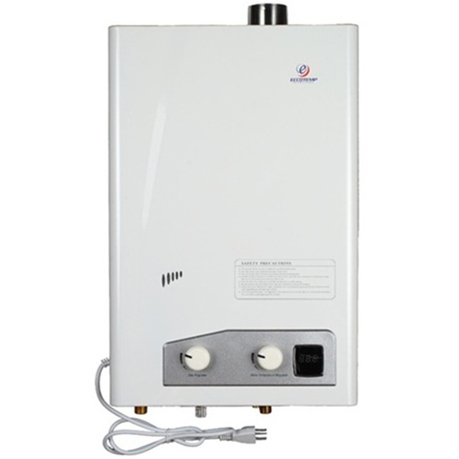

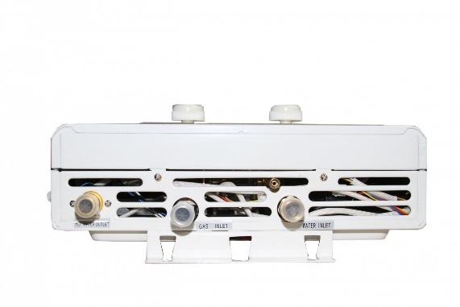

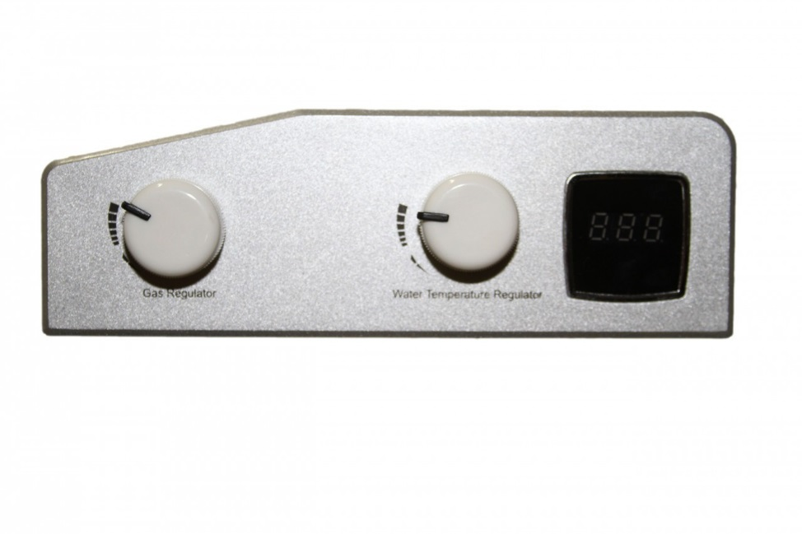
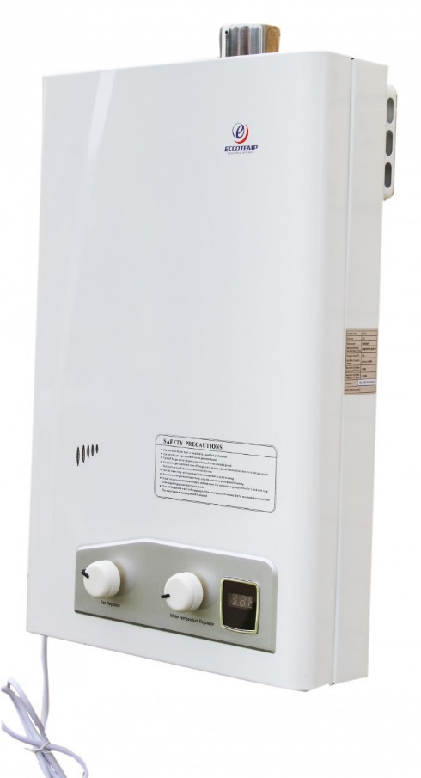
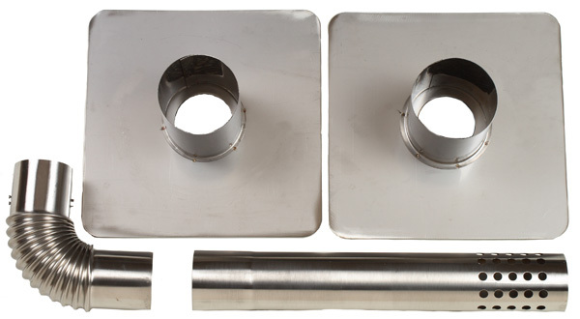

Product Description
The Eccotemp FVI12-LP Tankless Water Heater is a liquid propane fired, indoor tankless water heater designed for small to medium hot water production where you need more than one hot water application at the same time. The Eccotemp FVI12-LP Tankless Water Heater is perfect for vacation cabins, cottages and smaller homes.
Eccotemp FVI12-LP Tankless Water Heater comes with a horizontal stainless steel vent kit, read to install. The Eccotemp FVI12-LP's 120 volt UL listed power cord powers the internal exhaust fan and digital display. It only pulls about 2 watts idol and 1.07 Amps during operation.
The FVI12 offers a 45 degrees F temperature rise when operating at maximum flow capacity and a 77 degree F temperature rise at 2.3 GPM. Maximum temp of 150 degrees.
Some additional Features
- True 1/2" NPT water fittings
- Manual water temperature controls
- Liquid Propane Powered
- Sleek modern design
- 4 GPM flow capacity
- Power ventilation for safety and efficiency

Tested-Safe Electronic Ignition System
- 74,000 BTU
- Digital temperature display
- Fully independent gas and water controls
- Precise temperature and water flow adjustment
- Weighs only 33 pounds
- Unit Dimensions are 15”x24”x4”
- Stainless vent kit included
- Uses gas only when hot water is on
- Requires standard household 120 volt electric outlet
- UL listed electrical components
- Two year warranty
- *Not for use with a bilge pump
- Energy factor: 79%
- Hot water capacity range: 0.93 - 4.8 GPM
- Maximum / Minimum gas rate: 25,000 - 74,500 BTUs

